**NAME**  USAMA HAIDER

**REG NO** 19-NTU-CS-1129

**ASSIGNMENT TITLE**  News UI Assignment

**SUBMIT DATE** 09-04-2022

**SUBMIT TO** MA’AM AYESHA

MA’AM SARA

Sir Kamran

**Screen#1**

**Code:**

*// ignore_for_file: camel_case_type, camel_case_types*import 'package:flutter/material.dart';  
  
void main() {  
 runApp( const news_ui_scr1());  
}  
  
class news_ui_scr1 extends StatefulWidget {  
 const news_ui_scr1({Key? key}) : super(key: key);  
  
 @override  
 State<news_ui_scr1> createState() => _news_ui_scr1State();  
}  
  
class _news_ui_scr1State extends State<news_ui_scr1> {  
 @override  
 Widget build(BuildContext context) {  
 return MaterialApp(  
 home: Scaffold(  
 body:SingleChildScrollView(  
 child: Column(  
 children: [  
 Row(  
 mainAxisAlignment: MainAxisAlignment.center,  
 children: const [  
 Padding(  
 padding: EdgeInsets.only(top: 50),  
 child: CircleAvatar(  
 backgroundImage: AssetImage('assets/News/bbc.png'),  
 radius: 70,  
 ),  
 ),  
 ],  
 ),  
 *// ignore: prefer_const_constructors* Row(  
 mainAxisAlignment: MainAxisAlignment.center,  
 children: const [  
 Text("Flutter is Awesome" , style: TextStyle(fontSize: 40),  
 ),  
 ],  
 ),  
 Row(  
 mainAxisAlignment: MainAxisAlignment.center,  
 children: const [  
 Text("Student" , style: TextStyle(fontSize:20),  
 ),  
 ],  
 ),  
 const Divider(  
 indent: 40,  
 endIndent: 40,  
 height: 30,  
 ),  
 Row(  
 mainAxisAlignment: MainAxisAlignment.spaceEvenly,  
 children: [  
 Column(  
 children: const [  
 Text('872.4K' , style: TextStyle(fontSize: 30),),  
 Text('Hits' , style: TextStyle(fontSize: 20),),  
 ],  
 ),  
 Column(  
 children: const [  
 Text('6.5M' , style: TextStyle(fontSize: 30),),  
 Text('Followers' , style: TextStyle(fontSize: 20),),  
 ],  
 ),  
 Column(  
 children: const [  
 Text('127' , style: TextStyle(fontSize: 30),),  
 Text('Following' , style: TextStyle(fontSize: 20),),  
 ],  
 ),  
 ],  
 ),  
 const Divider(  
 indent: 40,  
 endIndent: 40,  
 height: 30,  
 ),  
 Row(  
 mainAxisAlignment: MainAxisAlignment.spaceEvenly,  
 children: [  
 Expanded(  
 child: ElevatedButton(  
 onPressed: (){  
 setState(() {  
  
 });  
 },  
 style: ButtonStyle(  
 backgroundColor: MaterialStateProperty.*all*<Color>(Colors.*orange*),  
 shape: MaterialStateProperty.*all*<RoundedRectangleBorder>(  
 RoundedRectangleBorder(  
 borderRadius: BorderRadius.circular(25),  
 side: const BorderSide(color: Colors.*red*)  
 )  
 )  
 ),  
 child: const Text('Follow'),  
 )),  
 Expanded(  
 child: TextButton(  
 child: const Text('Websites'),  
 onPressed: (){  
 setState(() {  
  
 });  
 },  
 )),  
 ],  
 ),  
 const Divider(  
 indent: 40,  
 endIndent: 40,  
 height: 30,  
 ),  
 Row(  
 mainAxisAlignment: MainAxisAlignment.spaceEvenly,  
 children: [  
 Column(  
 children: const [  
 Text('Top News' , style: TextStyle(color: Colors.*black* , fontSize: 20),),  
 Divider(  
 indent: 40,  
 endIndent: 40,  
 height: 30,  
 color: Colors.*orange*,  
 ),  
 ],  
 ),  
 Column(  
 children: const [  
 Text('Recent' , style: TextStyle(color: Colors.*black* , fontSize: 20),),  
 Divider(  
 indent: 40,  
 endIndent: 40,  
 height: 30,  
 color: Colors.*white*,  
 ),  
 ],  
 ),  
 ],  
 ),  
 Container(  
 child:  
 Column(  
 children: [  
 Row(  
 children:[  
 Column(  
 children: [Image.asset('assets/News/doctor.png')],  
 ),  
 Column(  
 children: [  
 Row(  
 children: [  
 Column(  
 children: [  
 Row(  
 children:const [  
 Text('wow! USA Develops the New \n and fast ways...\n'),  
 ]  
 ),  
 Row(  
 children: [  
 Column(children: const [  
 Text('Osama'),  
  
 ],  
 ),  
 const Divider(  
 indent: 40,  
 endIndent: 40,  
 height: 30,  
 ),  
 Column(children: [  
 ElevatedButton(onPressed: (){},  
 style: ButtonStyle(  
 backgroundColor: MaterialStateProperty.*all*<Color>(Colors.*orange*),  
 shape: MaterialStateProperty.*all*<RoundedRectangleBorder>(  
 RoundedRectangleBorder(  
 borderRadius: BorderRadius.circular(25),  
 )  
 )  
 ),  
 child: const Text('Health'))  
  
 ],  
 )  
 ],  
 )  
 ],  
 ),  
  
   
 ],  
 )  
 ],  
 ),  
 ],  
 ),  
 ],  
 )  
 ),  
 const Divider(  
 indent: 40,  
 endIndent: 40,  
 height: 30,  
 ),  
 Container(  
 child:  
 Column(  
 children: [  
 Row(  
 children:[  
 Column(  
 children: [Image.asset('assets/News/sport.png')],  
 ),  
 Column(  
 children: [  
 Row(  
 children: [  
 Column(  
 children: [  
 Row(  
 children:const [  
 Text('Pakistan launch a football \n team with a new passion \n'),  
 ]  
 ),  
 Row(  
 children: [  
 Column(children: const [  
 Text('Osama'),  
  
 ],  
 ),  
 const Divider(  
 indent: 40,  
 endIndent: 40,  
 height: 30,  
 ),  
 Column(children: [  
 ElevatedButton(onPressed: (){},  
 style: ButtonStyle(  
 backgroundColor: MaterialStateProperty.*all*<Color>(Colors.*orange*),  
 shape: MaterialStateProperty.*all*<RoundedRectangleBorder>(  
 RoundedRectangleBorder(  
 borderRadius: BorderRadius.circular(25),  
 )  
 )  
 ),  
 child: const Text('Sport'))  
  
 ],  
 )  
 ],  
 )  
 ],  
 ),  
  
  
 ],  
 )  
 ],  
 ),  
 ],  
 ),  
 ],  
 )  
 )  
 ],  
 ),  
 ),  
 ),  
 );  
 }  
}

**Output:**

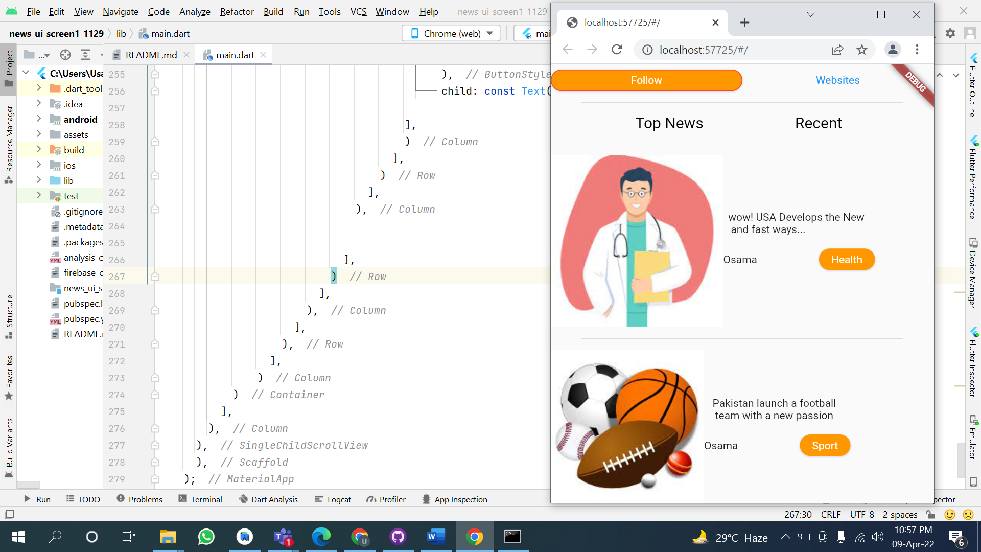

**Screen#2**

**Code:**

import 'package:flutter/material.dart';  
  
void main() => runApp(const newsScreen2());  
class newsScreen2 extends StatelessWidget {  
 const newsScreen2({Key? key}) : super(key: key);  
  
 @override  
 Widget build(BuildContext context) {  
 return MaterialApp(  
 home: Scaffold(  
 body:SingleChildScrollView(  
 child: Padding(  
 padding: const EdgeInsets.only(top: 40),  
 child: Container(  
 child: Column(  
 children: [  
 Row(  
  
 mainAxisAlignment: MainAxisAlignment.spaceAround,  
 children: [  
 Text('Search Result'),  
 Text('22.423 Founds')  
 ],  
 ),  
 Container(  
 child:  
 Card(  
 child: Column(  
 mainAxisSize: MainAxisSize.min,  
 children: <Widget>[  
 ListTile(  
 leading: CircleAvatar(  
 child: Image.asset('assets/News/bbc.png')  
 ),  
 title: Text("BBC News"),  
 subtitle: Text("6.5M Followers"),  
 trailing: ElevatedButton(onPressed: () {},  
 style: ButtonStyle(  
 backgroundColor: MaterialStateProperty.all<Color>(Colors.blue),  
 shape: MaterialStateProperty.all<RoundedRectangleBorder>(  
 RoundedRectangleBorder(  
 borderRadius: BorderRadius.circular(25),  
 )  
 )  
 ),  
 child: Text('Following')),  
 ),  
  
 const Divider(  
 indent: 40,  
 endIndent: 40,  
 height: 30,  
 ),  
  
 ListTile(  
 leading: CircleAvatar(  
 child: Image.asset('assets/News/cnet.png')  
 ),  
 title: Text("CNN "),  
 subtitle: Text("6M Following"),  
 trailing: ElevatedButton(onPressed: () {},  
 style: ButtonStyle(  
 backgroundColor: MaterialStateProperty.all<Color>(Colors.orange),  
 shape: MaterialStateProperty.all<RoundedRectangleBorder>(  
 RoundedRectangleBorder(  
 borderRadius: BorderRadius.circular(25),  
 )  
 )  
 ),  
 child: Text('Follow')),  
 ),  
  
 const Divider(  
 indent: 40,  
 endIndent: 40,  
 height: 30,  
 ),  
  
 ListTile(  
 leading: CircleAvatar(  
 child: Image.asset('assets/News/cnn.png')  
 ),  
 title: Text("CNET"),  
 subtitle: Text("127K Followers"),  
 trailing: ElevatedButton(onPressed: () {},  
 style: ButtonStyle(  
 backgroundColor: MaterialStateProperty.all<Color>(Colors.blue),  
 shape: MaterialStateProperty.all<RoundedRectangleBorder>(  
 RoundedRectangleBorder(  
 borderRadius: BorderRadius.circular(25),  
 )  
 )  
 ),  
 child: Text('Following')),  
 ),  
  
 const Divider(  
 indent: 40,  
 endIndent: 40,  
 height: 30,  
 ),  
 ListTile(  
 leading: CircleAvatar(  
 child: Image.asset('assets/News/daily.png')  
 ),  
 title: Text("Daily News "),  
 subtitle: Text("6M Following"),  
 trailing: ElevatedButton(onPressed: () {},  
 style: ButtonStyle(  
 backgroundColor: MaterialStateProperty.all<Color>(Colors.blue),  
 shape: MaterialStateProperty.all<RoundedRectangleBorder>(  
 RoundedRectangleBorder(  
 borderRadius: BorderRadius.circular(25),  
 )  
 )  
 ),  
 child: Text('Following')),  
 ),  
  
 const Divider(  
 indent: 40,  
 endIndent: 40,  
 height: 30,  
 ),  
 ListTile(  
 leading: CircleAvatar(  
 child: Image.asset('assets/News/buz.png')  
 ),  
 title: Text("Buzz Feed "),  
 subtitle: Text("6M Following"),  
 trailing: ElevatedButton(onPressed: () {},  
 style: ButtonStyle(  
 backgroundColor: MaterialStateProperty.all<Color>(Colors.blue),  
 shape: MaterialStateProperty.all<RoundedRectangleBorder>(  
 RoundedRectangleBorder(  
 borderRadius: BorderRadius.circular(25),  
 )  
 )  
 ),  
 child: Text('Following')),  
 ),  
  
 const Divider(  
 indent: 40,  
 endIndent: 40,  
 height: 30,  
 ),  
 ListTile(  
 leading: CircleAvatar(  
 child: Image.asset('assets/News/time.png')  
 ),  
 title: Text("Time News "),  
 subtitle: Text("12K Following"),  
 trailing: ElevatedButton(onPressed: () {},  
 style: ButtonStyle(  
 backgroundColor: MaterialStateProperty.all<Color>(Colors.blue),  
 shape: MaterialStateProperty.all<RoundedRectangleBorder>(  
 RoundedRectangleBorder(  
 borderRadius: BorderRadius.circular(25),  
 )  
 )  
 ),  
 child: Text('Following')),  
 ),  
  
 const Divider(  
 indent: 40,  
 endIndent: 40,  
 height: 30,  
 ),  
 ListTile(  
 leading: CircleAvatar(  
 child: Image.asset('assets/News/usa.png')  
 ),  
 title: Text("USA News "),  
 subtitle: Text("50K Following"),  
 trailing: ElevatedButton(onPressed: () {},  
 style: ButtonStyle(  
 backgroundColor: MaterialStateProperty.all<Color>(Colors.orange),  
 shape: MaterialStateProperty.all<RoundedRectangleBorder>(  
 RoundedRectangleBorder(  
 borderRadius: BorderRadius.circular(25),  
 )  
 )  
 ),  
 child: Text('Follow')),  
 ),  
  
 const Divider(  
 indent: 40,  
 endIndent: 40,  
 height: 30,  
 ),  
  
 ],  
 ),  
 ),  
  
 )  
 ]  
 ),  
 ),  
 ),  
 ),  
 ),  
 );  
 }  
}

**Output:**

